**Greed Specification**

**Overview**

Greed is a game in which the player seeks to gather as many falling gems as possible. The game continues as long as the player wants more!

**Rules**

Greed is played according to the following rules.

* Gems (*) and rocks (o) randomly appear and fall from the top of the screen.
* The player (#) can move left or right along the bottom of the screen.
* If the player touches a gem they earn a point.
* If the player touches a rock they lose a point.
* Gems and rocks are removed when the player touches them.
* The game continues until the player closes the window.

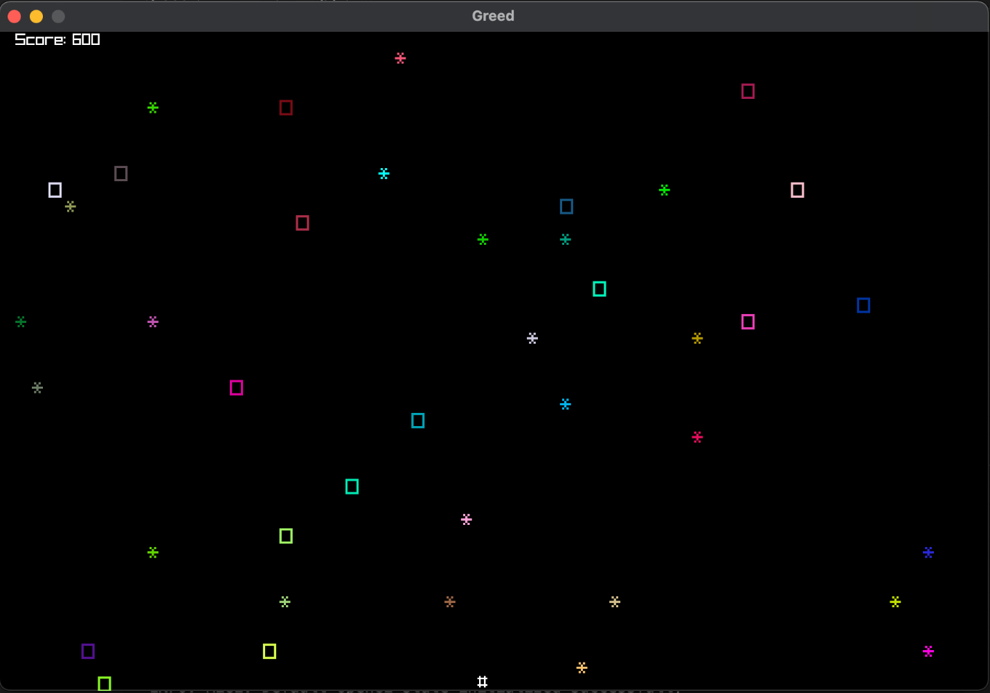

**Requirements**

* The program must have a README file.
* The program must have at least eight classes.
* Each module, class and method must have a corresponding comment.
* The game must remain generally true to the order of play described earlier.

Major differences to RFK:

* Actor
  + Stays at the bottom of the screen
  + Movement limited from left to right
* Artifact
  + Has only 2 symbols for Rock and Gem
  + Disappears on contact with Actor
  + Moves down to the bottom of the screen
* Score Display
  + Instead of a message, there is now a score on the place of the message.
  + Lose points when actor comes into contact with Rock, gain points if Gem

Coding Assignment

Jared and Dean: Actor and Artifact

Naomi and Ezequiel: Artifact and Score Display